

Android Application User Manual

The a Team

XBCAD7319 | Work Integrated Learning | 25/11/2024

Contents

Why was the application created 2

App Features: 2

Flow of the Application: 0

Diagram: 0

Screenshots of the application 0

# Why was the application created

The SparkLineHR platform was created to solve the problem that SparkLine Finance has of currently using paper-based systems to track employee information. The Android application contributing towards the SparkLineHR system was created for employees to view their own information such as their pays lips, and performance reviews that have been uploaded by HR and will rate their performance at work and will allow them to submit information to HR such as timesheets, leave requests, incident reports, and updates to their personal information.

# App Features:

Self-Service Portal:

Within the self-service portal, there will be four sections for users to choose from:

* + View personal Information – The view personal information screen will display the user’s full name, job title, work email address, and phone number that was input by HR on the web app side.
  + Update personal information – This screen will allow users to update both their contact information, and the information of their emergency contact that was listed during onboarding. The contact details that can be changed are the phone number, email address, and home address of the user, and these details will all need to be entered again even if the other details have not changed. The emergency contact details that can be changed are the contacts name, phone number, and relationship to the employee.
  + View pay slip history – This feature will allow users to view a history of all previous pay slips that have been released by HR, and they will be able to view all the pay slip information for each month that they have been at the company such as their gross pay and their net pay that will be calculated through the app. The pay slips can then be downloaded as a pdf file to be uploaded elsewhere or kept permanently by the employees, which will show all the information that displays on the screen.
  + View pending requests – This feature will allow the user to see overtime requests and leave requests that are still pending, and that have not been accepted or declined by HR. These requests will just show the date that they have been requested for, but the user cannot view the details of the requests.

Submit Timesheet:

* The timesheet submission screen will allow users to enter the number of hours that they have worked every day for a certain week. If there is already an accepted leave request on the dates that are being selected, the user will not be allowed to enter hours for those dates, and the hours will automatically be set to 0. The employee will also not be able to enter timesheet hours for days that are past the current date that they are entering on. If the hours entered by the user are over 40, it will automatically be sent to HR as an overtime request, and if they are over 50, it will not allow the user to input the timesheet. If the user submits a timesheet, and then wants to update their hours, or add for the next day, they must only input the hours that they wish to add on to the already existing hours, not input the new total value.

Leave Requests:

* The leave request feature will allow users to submit leave requests to HR to be accepted or declined. The user can select different types of leave to take and will have to enter the first day of leave, as well as the first day that the employee will be back at work. If the user has selected sick leave, they will be required to upload a doctor’s note to the app, and if they select any other type of leave the document will not be uploaded. These leave requests will send to a database to then be accepted or declined, and when they are accepted, it will reflect in the timesheet submission screen.

Development and Goals:

* This feature will allow users to view the details of training courses that have been uploaded by HR, as well as performance reviews related to the specific user. The user will also be able to add, update, view, and delete goals that they have set for themselves. The goals feature is meant as a motivational feature for the employee, and cannot be viewed by HR unless the employee chooses to show them from the app.

Incident and Feedback Reporting

* This screen will allow users to submit issue reports to HR either with their employee number attached, or anonymously so that HR will not know which employee submitted it.

# Flow of the Application:

## A diagram of a flowchart Description automatically generated Diagram:

Screenshots of the application

Splash Screen:

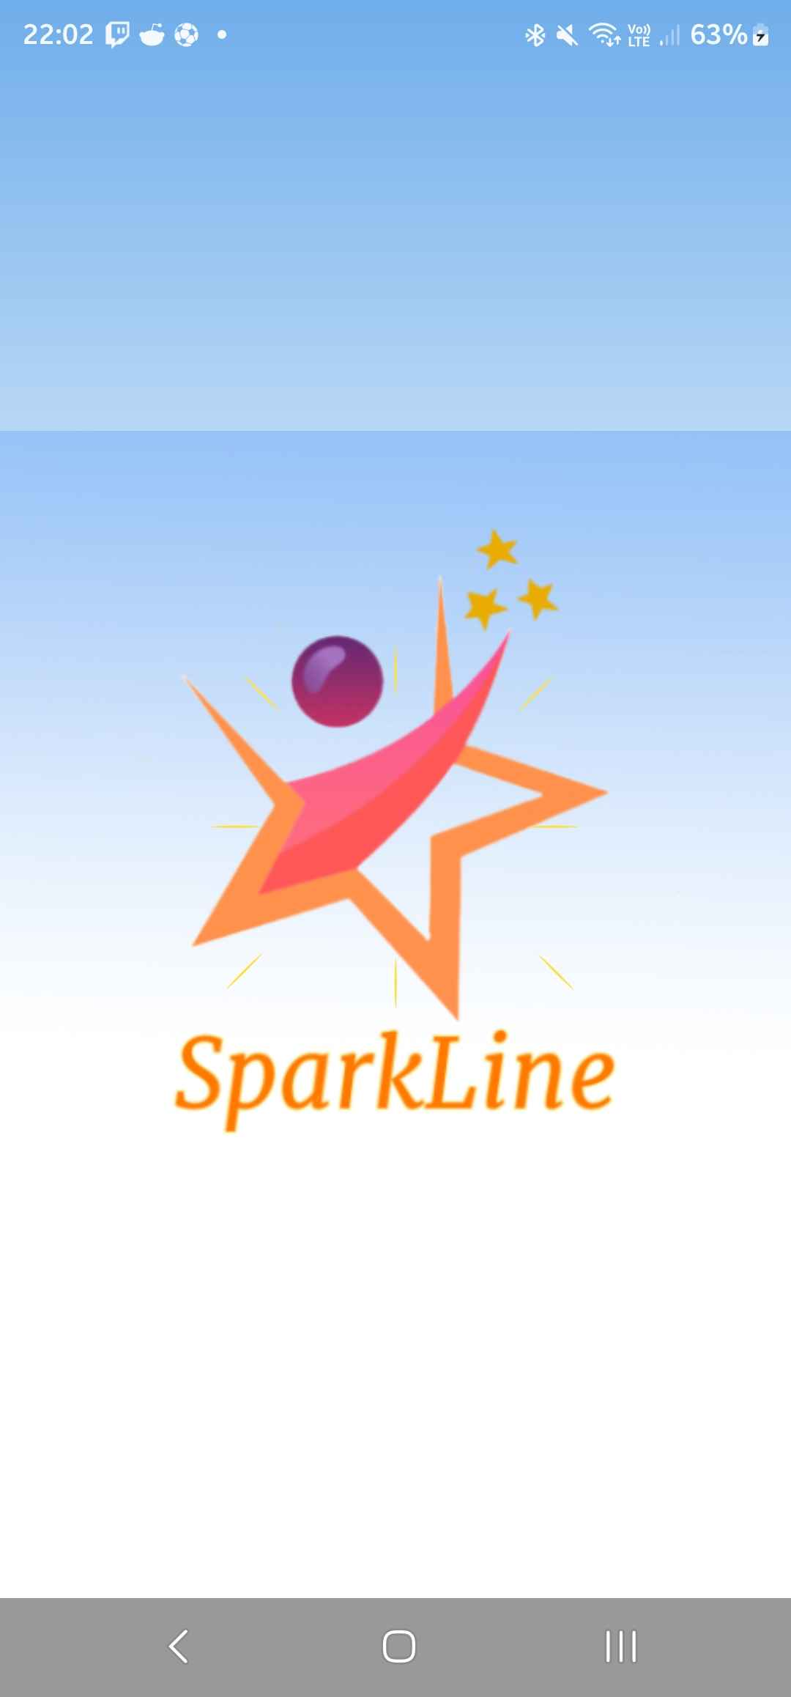

Figure 1: This screen will display when the user first starts the app and will display an animation before taking them to the login screen (Figure 2).

Figure : Splash Screen (SparkLine, 2024)

Login Process:

Figure 2: This is the login screen that will display after the splash screen has finished displaying and will allow users to either log in with their employee number one-time PIN if they are a new user, or with their employee number and new password if they have changed that.

Figure : Login Screen (SparkLine, 2024)

Change Password:

Figure 3: The change password screen will only display when the employee logs in with their one-time PIN, and will allow the user to enter a new password for future sign-ins. This screen will also display when the HR resets the employees password.

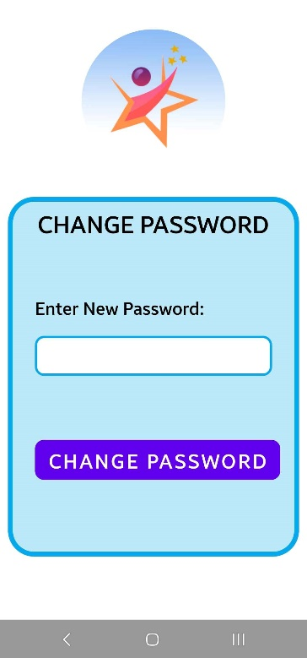

Figure : Change Password Screen (SparkLine, 2024)

Employee Dashboard:

Figure 4: This screen will display after the user has logged in with their password, and will show options for a Self-Service Portal, a Timesheet Submission, a Leave Request Submission, Development and Goals Viewing, and Incident and Feedback Reporting.

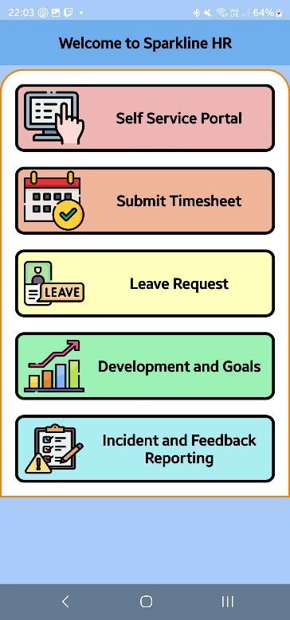

Figure : Employee Dashboard (SparkLine, 2024)

Self- Service Portal

Figure 5: The Self-Service Portal will give employees options to View their Personal Information, update their Personal Information such as Contact Information and their Emergency Contact Information. The employees can also view their pay slips through the Self-Service Portal, and they will be able to view the details about each pay slip. The last feature that is within this portal is that users can view pending leave requests that have not been accepted or declined by HR.

Figure : Self-Service Portal (SparkLine, 2024)

View Personal Information

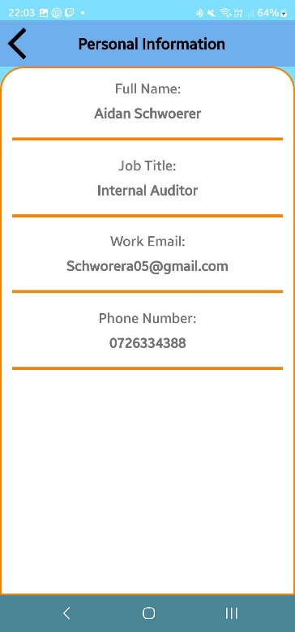

Figure 6: This screen will fetch the current user’s data and will display their full name, job title, work email linked to their account, and phone number.

Figure : View Personal Information (SparkLine, 2024)

Update Personal Information

Figure :Update Personal Info (SparkLine, 2024)

Figure :Update Contact Details (SparkLine, 2024)

Figure : Update Emergency Contact (SparkLine, 2024)

Figure 7: This screen will have buttons to take the user to the screens that will update contact details and update emergency contacts.

Figure 8: This screen will allow users to enter their new contact information, which will be their phone number, address, and email. Users will have to enter all details again, even if there are some details that did not change.

Figure 9: This screen will allow users to update their emergency contact, and they will have to enter the contacts name, relationship to the employee, and their phone number.

View Payslip History

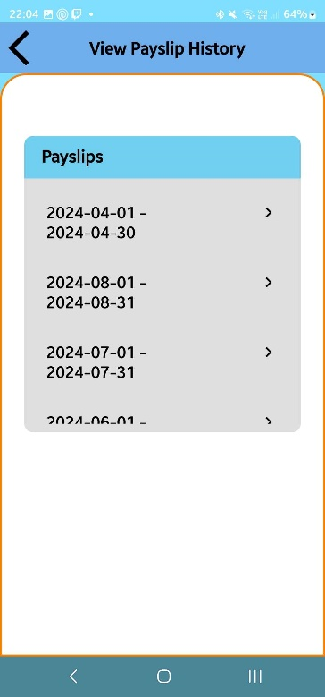

Figure : View Payslip History (SparkLine, 2024)

Figure : View Payslip Info 1 (SparkLine, 2024)

Figure : View Payslip Info 2 (SparkLine, 2024)

Figure 10: This screen will display a list of all pay slips that are relevant to the user to allow them to view information about their pay slips.

Figure 11: This screen will show the employee details that are related to their payment, such as their tax number and the period that the pay slip is for. The gross salary will be displayed to the user so that they can see the calculations for themselves.

Figure 12: This is the same screen as Figure 11 and will show the tax that the employee will pay on their pay slip, along with the amount that they will pay for UIF and pension based on the percentage chosen, and then they will be able to see the net pay that they will actually be receiving after deductions. This screen has a button that will allow the user to download their pay slip for the chosen month, which will download a pdf file that will show the same information as the screen.

View Pending Requests

Figure 13: This screen will load the dates of the overtime and leave requests that are still pending and that have not been either accepted or rejected by HR. These lists will display only the date and users will not be able to view the details of their requests on this screen.

Figure :View Pending Requests (SparkLine, 2024)

Submit Timesheet

Figure 14: This screen is where the user will be able to submit a timesheet. The user will not be able to enter timesheet hours for dates that are in the future, and they will also not be able to enter hours for dates that there is already an accepted leave request for. The app will calculate their total hours, and if the total is more than 40, it will automatically send it as an overtime request.

Figure : Submit Timesheet Screen (SparkLine, 2024)

Leave Request

Figure 15: This screen is where the user will be able to submit leave requests to HR for acceptance. The employee will be able to select different types of leave, and if the leave type is sick, they will have to upload a document such as a doctor’s note. Any other type of leave will not require any documents to be uploaded. The start date for the leave, and the date that the employee will return to work must also be entered by the user.

Figure : Leave Request Screen (SparkLine, 2024)

Development and goals

Figure 16: This screen will give the user the option to view their training courses completed, their goals that they have added, or the performance reviews that HR has uploaded for them.

Figure : Development and Goals (SparkLine, 2024)

Training

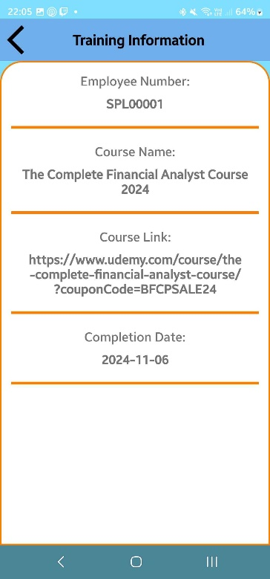

Figure 17: The user will be presented with a list of training courses that HR has posted, and that the employee has already completed. The employee will be able to choose from the list and view the details about the chosen course.

Figure 18: This page will display the details of the training course chosen, and will display the course name, course link, and date that the course was completed by the employee.

Figure :Training Completed (SparkLine, 2024)

Figure :Training Info (SparkLine, 2024)

Goals

Figure : Goals (SparkLine, 2024)

Figure : Add Goal (SparkLine, 2024)

Figure : View Goal Information (SparkLine, 2024)

Figure : Update Goal (SparkLine, 2024)

Figure 19: This screen will display a list of goals that the user has created, where they can choose to either add a new goal, view a chosen goal, edit the chosen goal, or delete the goal. Pressing on the orange pencil button will allow the user to edit the goal, and pressing the red bin button will allow the user to delete the chosen goal. Pressing the goal name will allow the user to view the goal details.

Figure 20: This screen is where the employee will add a new goal, and they will have to enter the goal name, date that they added the goal, date that they want to achieve the goal by, and a description of their goal.

Figure 21: This screen will allow the user to view the details of their goal and will display all information mentioned in the description of Figure 20, so that the user can remind themselves as to what the goal was, or when they needed to complete the goal by.

Figure 22: This screen will allow the user to populate all the relevant details of the goal, as mentioned in the Figure 20 description. The data will populate with information of what was originally entered for the goal.

Performance

Figure :Performance Reviews (SparkLine, 2024)

Figure :Performance Review Details (SparkLine, 2024)

Figure 23: This screen will display the performance reviews that HR has uploaded that are relevant to the current user. It will display in a list with the date that the review occurred on, so that users can choose the most recent requests.

Figure 24: This screen will display the details of the performance review that the employee has selected, and this will display the date that the review happened, the rating that the employee got from HR, and the feedback that HR would like them to work on.

Incident and Feedback Reporting

Figure 25: This screen will allow employees to report incidents to HR, and it will allow them to enter a title and a description of the incident. The employee has the option to either include their employee number with the report or remain anonymous.

Figure : Incident Reporting (SparkLine, 2024)